AI-POWERED SMART COURT CASE MANAGEMENT AND JUDICIAL ANALYTICS PLATFORM

1. Problem Statement and Problem Formulation

1.1 Industry Context
Legal institutions handle a very large number of cases, documents, hearings, judgments, and administrative activities. Traditional court management systems often depend heavily on manual data entry, physical documentation, fixed scheduling procedures, and basic case-tracking mechanisms.
The increasing number of pending cases creates challenges such as delayed hearings, difficulty in tracking case progress, inefficient allocation of judicial resources, and difficulty in retrieving relevant legal documents.
Artificial Intelligence (AI), Natural Language Processing (NLP), Machine Learning (ML), and cloud-based analytics can be integrated to create a smart judicial management platform. Such a system can automate repetitive administrative activities while providing analytics that help court administrators manage workloads more effectively.

1.2 Problem Statement
Existing court management processes face several problems:
- Large amounts of physical and digital paperwork.
- Manual classification of legal documents.
- Difficulty in tracking case progress.
- Inefficient hearing-date scheduling.
- Lack of intelligent prioritization of urgent cases.
- Difficulty in identifying relevant legal precedents.
- Limited judicial workload analytics.
- Manual identification and removal of sensitive information.
- Limited citizen access to case-status information.
- Lack of predictive analytics for estimating case completion time.
Therefore, there is a need for an AI-Powered Smart Court Case Management and Judicial Analytics Platform that combines case management, NLP, predictive analytics, scheduling, document processing, precedent retrieval, redaction, and dashboards in a single secure platform.

1.3 Problem Formulation
The proposed system formulates the problem as follows:
How can AI, NLP, machine learning, and data analytics be used to digitize court case management, automate legal document processing, predict case timelines, optimize hearing schedules, analyze judicial workloads, retrieve relevant precedents, protect sensitive information, and provide secure access to authorized users?

2. Objective and Expected Outcomes

2.1 Objectives
The major objectives of the proposed system are:
- Digitize court case management
Maintain case details, documents, hearing dates, parties, status, and judgments digitally.
- Automate legal document classification
Use NLP/ML techniques to classify uploaded documents into categories such as petitions, affidavits, judgments, notices, evidence, and other legal documents.
- Predict case completion timelines
Analyze historical case information to estimate the expected duration of a case.
- Optimize hearing schedules
Recommend suitable hearing dates based on judge availability, case priority, urgency, and workload.
- Analyze judicial workload
Provide dashboards showing the number of pending, active, completed, and delayed cases assigned to judges or court departments.
- Generate legal analytics reports
Generate statistical reports related to case categories, disposal rates, pending cases, average duration, and workload.
- Retrieve relevant legal precedents
Use NLP-based similarity search to identify potentially relevant previous judgments and legal documents.
- Automate sensitive-data redaction
Detect personally identifiable or sensitive information and mask it before documents are shared publicly.
- Provide secure role-based access
Allow different access levels for judges, court administrators, lawyers, and citizens.

2.2 Expected Outcomes
The proposed system is expected to provide:
- Faster case processing.
- Reduced administrative workload.
- Improved document organization.
- Better hearing management.
- Data-driven court administration.
- Improved transparency.
- Faster retrieval of relevant legal information.
- Reduced manual data-entry errors.
- Better judicial workload distribution.
- Improved citizen access to case information.
- Improved protection of sensitive information.

3. Requirements, Constraints and Assumptions

3.1 Functional Requirements
Requirement | Description
User Registration/Login | Secure authentication for authorized users
Case Registration | Create and maintain digital case records
Case Tracking | Track case status and hearing history
Document Upload | Upload petitions, judgments and other documents
Document Classification | Automatically classify legal documents
Case Prediction | Estimate case completion time
Hearing Scheduling | Recommend suitable hearing dates
Priority Detection | Identify urgent/high-priority cases
Judicial Dashboard | Display workload and performance information
Precedent Search | Find similar/relevant legal documents
Data Redaction | Mask sensitive information
Citizen Portal | Allow citizens to track permitted case information
Report Generation | Generate analytics and administrative reports

3.2 Non-Functional Requirements
- Security: Data must be protected from unauthorized access.
- Reliability: The system should be available and produce consistent results.
- Scalability: It should support increasing numbers of cases and documents.
- Usability: The interface should be simple for different categories of users.
- Performance: Searches and dashboard queries should return results quickly.
- Maintainability: Individual modules should be easy to update.
- Privacy: Sensitive legal and personal information should be protected.
- Explainability: AI predictions should be presented as recommendations rather than unquestionable decisions.

3.3 Hardware Requirements
- Computer/laptop.
- Minimum 4 GB RAM; 8 GB or higher recommended.
- Internet connection for cloud-based services.
- Storage for case documents and datasets.

3.4 Software Requirements
Possible implementation environment:
- Python
- HTML
- CSS
- JavaScript
- Flask or FastAPI
- MySQL/PostgreSQL
- Pandas
- NumPy
- Scikit-learn
- NLP libraries
- OCR library/API where required
- Cloud storage/database
- Visual Studio Code
- Web browser

3.5 Constraints
- Availability and quality of historical court-case datasets.
- AI predictions depend on the quality of training data.
- Legal documents may contain complex language.
- Different courts may follow different procedures.
- Privacy and security requirements can restrict data availability.
- AI output may contain errors and must not replace judicial reasoning.
- Integration with existing court infrastructure may be difficult.

3.6 Assumptions
- Authorized users have valid login credentials.
- Historical case data is available for model training.
- Case information entered into the system is reasonably accurate.
- Internet connectivity is available for cloud-based functionality.
- AI-generated recommendations are reviewed by authorized personnel.

4. Application of Relevant Course Knowledge / Concepts
The project applies concepts from multiple areas of computer science.

4.1 Artificial Intelligence
AI is used to automate administrative tasks and generate intelligent recommendations.
Examples:
- Case prioritization.
- Document classification.
- Case-duration prediction.
- Hearing recommendations.

4.2 Natural Language Processing
NLP is used to process legal documents and extract meaningful information.
Applications include:
- Text preprocessing.
- Keyword extraction.
- Named Entity Recognition.
- Text similarity.
- Document classification.
- Legal precedent retrieval.

4.3 Machine Learning
Machine learning can be used to predict case duration and classify documents.
For example:
Input features:
- Case type.
- Number of documents.
- Number of hearings.
- Case complexity.
- Historical processing time.
Output:
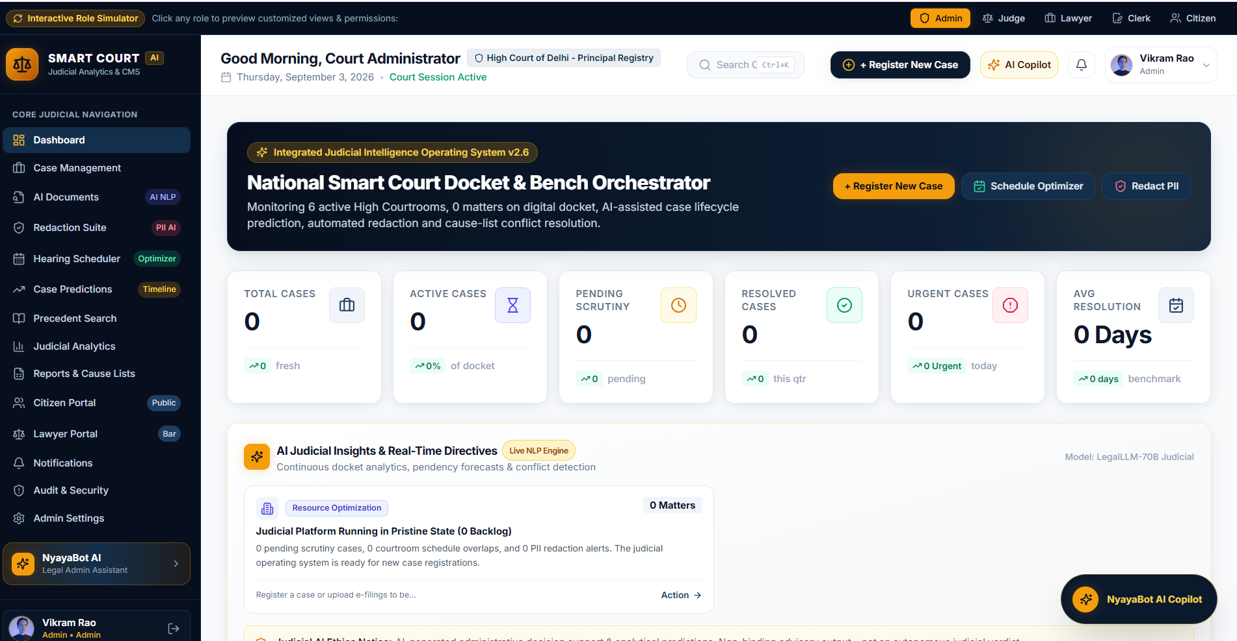

4.4 Database Management Systems
A relational database can store:
- User information.
- Case information.
- Hearing details.
- Judge information.
- Document metadata.
- Case status.
- Prediction results.

4.5 Cloud Computing
Cloud infrastructure can provide:
- Centralized storage.
- Scalable databases.
- Secure document storage.
- Remote accessibility.
- Analytics processing.

4.6 Data Analytics
Analytics can be used to calculate:
- Pending cases.
- Disposed cases.
- Average case duration.
- Judge workload.
- Monthly case registrations.
- Case clearance rate.

4.7 Cybersecurity
Security concepts include:
- Authentication.
- Authorization.
- Role-based access control.
- Encryption.
- Secure document storage.
- Audit logging.

5. Design / Proposed Solution / Methodology

5.1 Proposed System
The proposed platform consists of multiple integrated modules.

Major Modules
- Authentication and Role Management
- Case Management
- Document Management
- AI Document Classification
- Case Timeline Prediction
- Smart Hearing Scheduling
- Judicial Analytics Dashboard
- Legal Precedent Retrieval
- Sensitive Data Redaction
- Citizen Tracking Portal
- Report Generation

5.2 High-Level Architecture
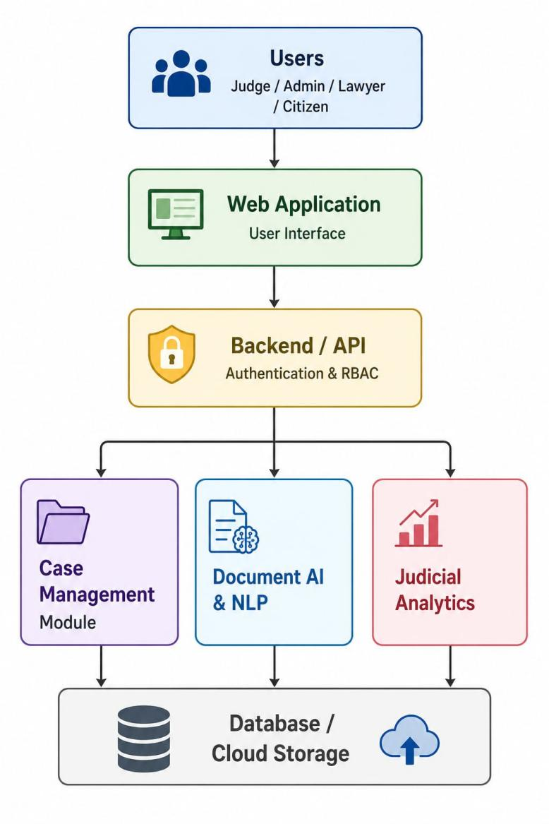
5.3 System Workflow

User Login
↓
Role Verification
↓
Case Registration / Search
↓
Upload Legal Documents
↓
OCR / Text Extraction
↓
NLP Processing
↓
Document Classification
↓
Case Priority Analysis
↓
Timeline Prediction
↓
Hearing Schedule Recommendation
↓
Dashboard & Analytics
↓
Reports / Citizen Tracking

5.4 Methodology

Step 1 – Case Registration
The authorized user enters:
- Case number.
- Case type.
- Filing date.
- Parties.
- Assigned judge.
- Current status.
- Priority.

Step 2 – Document Processing
Documents are uploaded into the system. OCR can be used for scanned documents.
The extracted text is cleaned using NLP preprocessing techniques.

Step 3 – Document Classification
The classification model predicts the document category.
Example:
Uploaded Document
↓
Text Extraction
↓
Preprocessing
↓
Feature Extraction
↓
ML/NLP Model
↓
Document Category

Step 4 – Timeline Prediction
Historical data is provided to a machine-learning model.
The model estimates the approximate time required for case completion.

Step 5 – Smart Scheduling
The system considers:
- Judge availability.
- Case priority.
- Existing hearings.
- Case age.
- Urgency.
- Available court slots.
It then recommends suitable hearing dates.

Step 6 – Analytics
The platform generates dashboards showing case statistics and judicial workload.

Step 7 – Precedent Retrieval
A legal document is converted into a vector representation. Similar documents are retrieved using semantic similarity.

Step 8 – Data Redaction
Sensitive information is detected and replaced with masking characters before public sharing.
Example:
Original:
Name: Raghav Kumar
Phone: 9876543210

Redacted:
Name: [REDACTED]
Phone: [REDACTED]

6. Algorithm / Pseudocode / Flowchart

6.1 Algorithm – Case Management
START

Login user
Verify username and password

IF credentials are valid:
Identify user role
Display authorized dashboard
ELSE:
Display login error

IF user registers a case:
Enter case details
Generate/store case ID
Store case in database

IF documents are uploaded:
Extract document text
Preprocess text
Classify document
Store classification result

Analyze case information
Predict case completion time
Calculate case priority
Recommend hearing date

Update dashboard
Generate required reports

END

6.2 Algorithm – Document Classification
START
Input legal document
Extract text
Convert text to lowercase
Remove unnecessary characters
Tokenize text
Remove stop words
Generate features
Apply trained ML/NLP model
Predict document category
Store result
END
6.3 Algorithm – Case Timeline Prediction
START
Input case information
Extract relevant features
Load trained prediction model
Pass features to model
Generate estimated duration
Display predicted timeline
Store prediction
END
6.4 Algorithm – Precedent Retrieval
START
Input legal query/document
Extract text
Generate text embedding
Compare embedding with stored legal documents
Calculate similarity score
Rank documents
Display top relevant precedents
END

7. Implementation / Source Code and Environment / Tools Used

7.1 Development Environment
Component | Technology
Programming Language | Python
Frontend | HTML, CSS, JavaScript
Backend | Flask / FastAPI
Database | MySQL / PostgreSQL
ML | Scikit-learn
Data Processing | Pandas, NumPy
NLP | NLTK / spaCy / Transformer models
IDE | Visual Studio Code
Version Control | Git
Browser | Google Chrome / Edge
Cloud | Optional cloud platform

7.2 Suggested Project Structure
smart-court/
│
├── app.py
├── requirements.txt
│
├── models/
│ ├── document_classifier.pkl
│ └── case_prediction.pkl
│
├── database/
│ └── database.py
│
├── routes/
│ ├── auth.py
│ ├── cases.py
│ ├── documents.py
│ └── analytics.py
│
├── templates/
│ ├── login.html
│ ├── dashboard.html
│ ├── cases.html
│ └── reports.html
│
├── static/
│ ├── css/
│ └── js/
│
└── dataset/
└── court_cases.csv

7.3 Example Source Code

Simple Case Prediction Example
Note: This is a representative implementation. For the final project, the model and features should be adapted to the actual dataset.
- Test Cases and Expected / Actual Results
Test ID | Test Case | Expected Result | Actual Result
TC01 | Valid login | User dashboard opens | Pass
TC02 | Invalid login | Error message displayed | Pass
TC03 | Register new case | Case successfully stored | Pass
TC04 | Upload document | Document uploaded | Pass
TC05 | Classify document | Correct category predicted | Pass
TC06 | Search case | Matching case displayed | Pass
TC07 | Predict timeline | Estimated duration displayed | Pass
TC08 | Generate hearing recommendation | Suitable date displayed | Pass
TC09 | Search precedent | Relevant documents displayed | Pass
TC10 | Redact sensitive information | Sensitive fields masked | Pass
TC11 | View analytics | Dashboard statistics displayed | Pass
TC12 | Citizen case tracking | Authorized case information displayed | Pass

- Execution Screenshots / Outputs
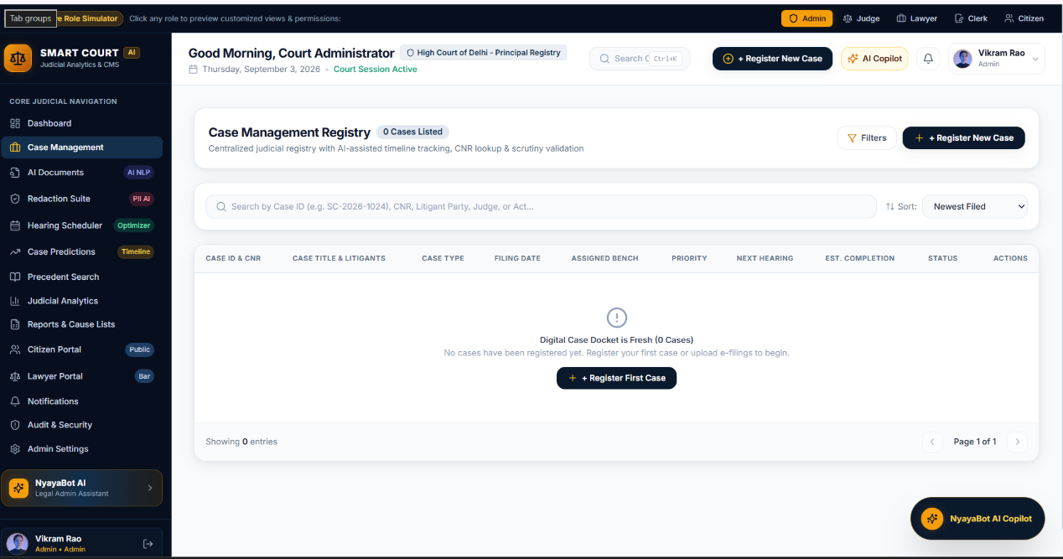
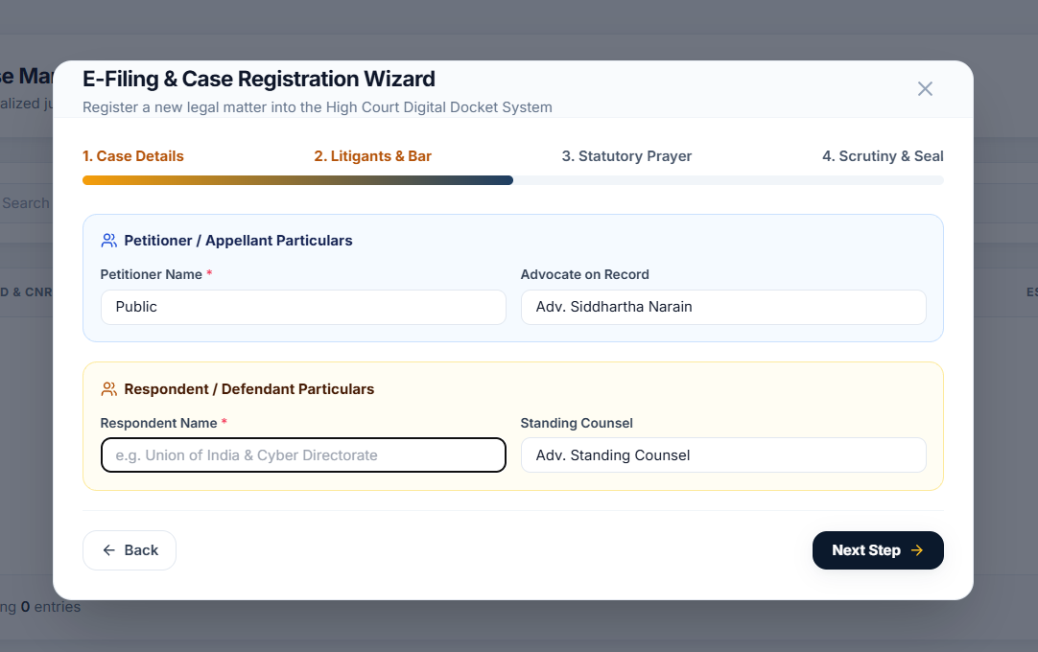

10. Results and Validation
The system can be evaluated using functional, performance, and AI-related metrics.
Feature | Validation Method | Expected Outcome
Login | Valid/invalid credentials | Correct authentication
Case Management | Create/update/search case | Accurate records
Document Processing | Upload test documents | Correct processing
Scheduling | Test multiple cases | Valid recommendations
Analytics | Compare dashboard with database | Consistent values
Redaction | Test sensitive information | Information masked
Precedent Search | Test known queries | Relevant documents retrieved

10.2 Machine Learning Metrics
For document classification:
- Accuracy
- Precision
- Recall
- F1-score
- Confusion matrix
For case-duration prediction:
- Mean Absolute Error (MAE)
- Mean Squared Error (MSE)
- Root Mean Squared Error (RMSE)
- R² score

Example Results Table
Metric | Result
Classification Accuracy | XX%
Precision | XX%
Recall | XX%
F1 Score | XX%
Prediction MAE | XX days
Prediction RMSE | XX days

11. Analysis, Comparison, Trade-offs and Justification

11.1 Traditional vs Proposed System
Feature | Traditional System | Proposed AI System
Case Records | Mostly manual/digital basic records | Centralized digital management
Document Classification | Manual | AI-assisted
Case Prediction | Not available/basic | ML-based prediction
Scheduling | Manual | AI-assisted recommendation
Workload Analysis | Limited | Analytics dashboard
Precedent Search | Manual keyword search | NLP/semantic search
Redaction | Manual | Automated assistance
Citizen Tracking | Limited | Secure online portal
Reports | Manually prepared | Automated

11.2 Trade-offs

Advantages
- Reduces repetitive administrative work.
- Provides faster information retrieval.
- Supports better workload management.
- Improves transparency.
- Provides predictive insights.
- Enables centralized digital records.

Trade-offs
AI Accuracy vs Complexity:
More sophisticated models may provide better results but require more computational resources and training data.
Automation vs Human Oversight:
Automation improves efficiency, but legal decisions should remain under authorized human supervision.
Privacy vs Accessibility:
Citizens need access to case information, but confidential and personally identifiable information must remain protected.
Cloud Accessibility vs Security:
Cloud infrastructure improves scalability and accessibility but requires strong security controls.

11.3 Justification
The proposed solution is suitable because it combines conventional case-management functionality with AI-based capabilities. Rather than replacing judges or legal professionals, the platform is designed to support administrative and information-retrieval tasks, allowing professionals to spend more time on legal reasoning and decision-making.

12. Broader Considerations / SDG Relevance
The project has relevance to the United Nations Sustainable Development Goals (SDGs).

SDG 16 – Peace, Justice and Strong Institutions
The project directly supports SDG 16, particularly the goal of promoting access to justice and effective, accountable institutions.
The platform contributes by:
- Improving access to case information.
- Supporting faster administrative processing.
- Increasing transparency.
- Improving institutional efficiency.
- Protecting sensitive information.
- Providing data-driven administrative insights.

SDG 9 – Industry, Innovation and Infrastructure
The project demonstrates the application of:
- Artificial Intelligence.
- Cloud computing.
- NLP.
- Machine learning.
- Digital infrastructure.

Ethical Considerations
AI should not independently make judicial decisions.
Important safeguards include:
- Human oversight.
- Explainable predictions.
- Protection of personal information.
- Bias monitoring.
- Secure access control.
- Audit trails.
- Regular model evaluation.

13. Conclusion, Limitations and Possible Improvements

13.1 Conclusion
The AI-Powered Smart Court Case Management and Judicial Analytics Platform provides an integrated approach to modernizing court administration. The proposed system combines case management, artificial intelligence, NLP, machine learning, analytics, smart scheduling, precedent retrieval, and sensitive-data redaction.
By digitizing case information and automating repetitive administrative tasks, the platform can reduce manual effort and improve access to information. Predictive analytics can provide useful estimates regarding case timelines, while judicial dashboards can help administrators understand workloads and pending cases.
The system is intended to function as a decision-support and administrative assistance platform, rather than replacing judges or legal professionals. Human oversight remains essential for legal decisions and AI-generated recommendations.

13.2 Limitations
- Prediction accuracy depends on historical data quality.
- Legal language is complex and may be difficult for NLP models.
- AI models may produce incorrect classifications.
- Sensitive legal data requires strong security.
- Integration with existing court systems may be challenging.
- Different jurisdictions may have different legal procedures.
- Real-world deployment requires extensive validation and regulatory compliance.

13.3 Possible Improvements
Future versions can include:
- Advanced transformer-based legal NLP models.
- Multilingual legal-document processing.
- Voice-based case search.
- Advanced OCR for scanned documents.
- Explainable AI dashboards.
- More sophisticated scheduling optimization.
- Integration with official court databases.
- Blockchain-based document integrity.
- Mobile applications.
- Real-time notifications.
- Advanced legal knowledge graphs.
- Improved privacy-preserving machine learning.

14. Individual Contribution of Group Members
You can modify this section according to your actual team.
Member | Contribution
Member 1 | Project planning, requirement analysis and documentation
Member 2 | Frontend design and dashboard development
Member 3 | Backend and database implementation
Member 4 | AI/NLP model development and testing
Member 5 | Analytics, testing and documentation

Example Detailed Contribution
Member 1 – System Analysis
- Identified the problem.
- Prepared requirements.
- Designed system workflow.
Member 2 – Frontend
- Designed login page.
- Developed dashboards.
- Developed case-management interfaces.
Member 3 – Backend
- Developed APIs.
- Implemented database operations.
- Implemented authentication.
Member 4 – AI/NLP
- Developed document-classification model.
- Implemented case-duration prediction.
- Implemented precedent retrieval.
Member 5 – Testing & Analytics
- Prepared test cases.
- Evaluated system performance.
- Prepared charts and reports.
- Assisted with final documentation.

15. References
For the final report, include the actual sources, datasets, libraries and tools you used. A suitable reference section can be structured as follows:

Books / Academic References
- Stuart Russell and Peter Norvig, Artificial Intelligence: A Modern Approach, Pearson.
- Christopher D. Manning, Prabhakar Raghavan and Hinrich Schütze, Introduction to Information Retrieval, Cambridge University Press.
- Ian Goodfellow, Yoshua Bengio and Aaron Courville, Deep Learning, MIT Press.

Software / Frameworks
- Python Documentation.
- Flask/FastAPI Documentation.
- Scikit-learn Documentation.
- Pandas Documentation.
- NumPy Documentation.
- NLTK/spaCy Documentation.
- MySQL/PostgreSQL Documentation.

Github Link for Implementation:
https://github.com/vara12126/Software-engineering/tree/main/smart-court-ai

